PRODUCT DATA SHEET

D3032 - Double-Coated Polyethylene Foam Tape

Description: Features:

A double-coated polyethylene tape that works great on various substrates and offers permanent bonding to metals, woods, and plastics. It will fill gaps on irregular surfaces and is ideal for dampening vibrations and distributing stress. This foam is flexible and will conform to many surfaces. Typical applications for this product are done indoors.
- Permanent bond
- Highly conformable
- Easily die cut
- Closed cell foam to prevent water absorption
- High load bearing ability
- Wide temperature range

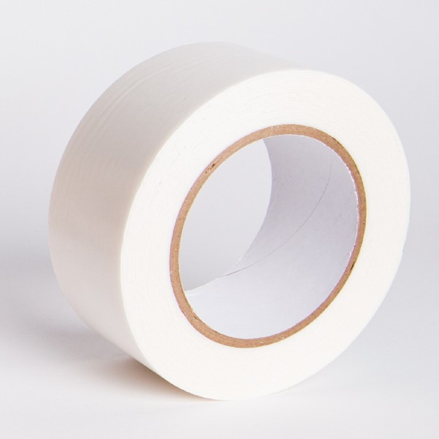
Product Data
Carrier | Polyethylene Foam | 31 mil | 0.79 mm
Adhesive (both sides) | Acrylic | 2 mil | 0.05 mm
Liner | Kraft Paper | 5 mil | 0.13 mm
Total Tape Thickness | Excluding Liner | 35 mil | 0.84 mm
Peel Adhesion | From Stainless Steel | 63 oz/in | 17 N/25 mm
Tensile Strength | - | 76.5 oz/in | 21 N/25 mm
Elongation | - | 265%
Tear Strength | - | 686 oz/in | 191 N/25 mm
Service Temperature Range | - | -40° to 250°F | -40° to 121°C
Color | - | White

Assembly | Bonding
Masking | Splicing

Application Notes:
Indoor bonding of plastics, metals, woods, sound attenuation, cushioning or spacer applications and lightweight shim. Similar to 3M 4008, 3M 4016, and 3M 4032.

To achieve ultimate adhesion, the bonding surface should be dry, clean and free of dirt and oils. The strength of the adhesive bond is dependent on the amount of surface area directly contacting the adhesive. Firm pressure is recommended to obtain good adhesive to surface contact.
Note: Values should not be used for specification purposes. Each user should make their own test to determine the products suitability for their own intended use and shall assume all risks and liabilities in connection therewith. Materials should be stored at 70°F (21°C) with 50% relative humidity

Good | Better | Best | Not Recommended
800-545-8273 • 262-835-0748 • Fax: 262-835-0749 • www.specialtytapes.net 4221 Courtney Road • Franksville, WI 53126

