PRODUCT DATA SHEET

FM525-Kraft Flatback

Description: Features:

An aggressive pressure sensitive flatback with a rubber-based adhesive that has been specifically designed to offer a strong and secure seal on a variety of paper-based substrates. The tape is designed for a wide range of temperatures and humidities and can be easily applied to most surfaces.
- Kraft brown color
- Higher adhesion than other flatbacks
- Used in picture frame sealing, carton sealing, splicing, core startup, book binding, and other packaging applications.
- Strong paper tape while still hand-tearable

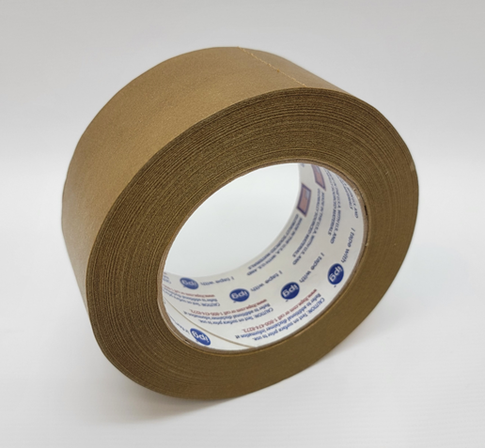
Product Data
Carrier | Kraft Flatback Paper
Adhesive | Synthetic Rubber
Liner | None
Total Tape Thickness | - | 5.5 mils | 0.14 mm
Peel Adhesion | From Stainless Steel | 85 oz/in | 23.6 N/25 mm
Temperature Resistance | - | 220°F | 104°C
Color | Brown

Assembly | Bonding
Masking | Splicing

Application Notes:

A tape used for indoor bonding of papers and cardboard for splicing, packaging, frame sealing, tail tabbing, direct printing, and book binding. This tape should be considered when a typical paper masking tape does not provide enough strength for the application.

To achieve ultimate adhesion, the bonding surface should be dry, clean and free of dirt and oils. The strength of the adhesive bond is dependent on the amount of surface area directly contacting the adhesive. Firm pressure is recommended to obtain good adhesive to surface contact.
Note: Values should not be used for specification purposes. Each user should make their own test to determine the products suitability for their own intended use and shall assume all risks and liabilities in connection therewith. Materials should be stored at 70°F (21°C) with 50% relative humidity

Good | Better | Best | Not Recommended
800-545-8273 • 262-835-0748 • Fax: 262-835-0749 • www.specialtytapes.net 4221 Courtney Road • Franksville, WI 53126

