STM-Low Noise Packaging Tape
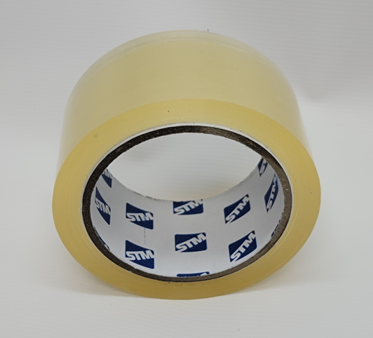

PRODUCT DESCRIPTION
STM-Low Noise Packaging Tape is a clear color packaging tape with low unwind noise. This tape has excellent holding capacity and high tensile strength. It can be used to stick and seal any type of box. It provides smooth unwind and quiet release.
- Smooth unwind & quiet release
- Anti-aging and anti-corrosion
- Premium sticking power
- Heat resistant and anti-freezing
- No slivering, splitting or tearing
- Can be used to stick and seal any type of box
- Custom printing

TYPICAL APPLICATIONS
Used for general sealing, wrapping, enclosing, and bundling to prepare items for handling, storage, or shipping. Can be used with any type of box. Recommended for use on light weight to average cartons up to 88 pounds (40 kg).

SPECIFICATION
Clear
BOPP
Water-based Acrylic
2.0 mils
20 oz/in
Color:
Carrier:
Adhesive:
Total Thickness:
Peel Adhesion:

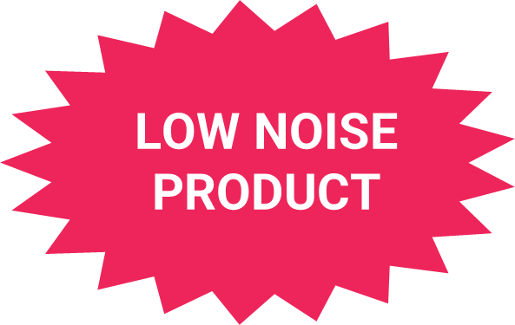
800-545-8273 | specialtytapes.net
sales@specialtytapes.net | Fax: 262-835-0749 | STM 4221 Courtney Road, Franksville, WI 53126 USA

